[Name]
[Institution affiliation]
[Course]
[Professor]
[Date]

Economic Order Quantity (EOQ) in the Apparel Industry
The Economic Order Quantity (EOQ) is defined as the order quantity helping in minimizing the order and holding costs for a business (Garrison, Noreen, & Brewer, 2021). Overall, EOQ is the optimum product’s amount that need to be ordered at a given point at a minimal total annual ordering and carrying cost (Garrison et. Al, 2021). Therefore, firms must be focused on the number of products they should produce to be purchased while maintaining a supply chain that is cost-efficient. With such knowledge, EOQ is well utilized across the fashion apparel industry because of a highly volatile demand and short lifecycles of the products. Therefore, the fashion apparel industry needs a keen consideration during the initial periods of ordering prior to the selling season and in the midst of the selling periods, based on price and replenishment decisions. As a result, inventory planning decisions remain critical across the fashion apparel industry (Garrison et. Al, 2021).
In this case, EOQ remains relevant to Li & Fung Limited Company that is in the apparel industry. Research shows that the apparel industry had been experiencing shrinking batch sizes and Li & Fung is one of the supply chain management company that is highly affected. The firm’s average orders’ size had been on the decline for years, and it is expected to continue declining until the firm approaches a unit of one (Khan, Natasha, 2018). Such a trend had been increasingly rising since the internet had been enabling 24-hours shopping for consumers. This strategy had been encouraging consumers to expect a constant access to new custom-tailored clothing styles because various firms had been exploring the “click, buy, and make” order-to-delivery platforms (Khan, Natasha, 2018). As a result, such a strategy had been enabling these companies into using intensive technology manufacturing activities in producing garments in batch sizes of one (Khan, Natasha, 2018).
Given the above knowledge, Li & Fung Limited had been using significant EOQ metrics to determine the optimal quantity that should be purchased when orders are made. One of the significant EOQ metric is the production batch, alias the line efficiency. This metric is used in measuring the efficiency of a production line on a daily basis (Garrison et. Al, 2021). Therefore, the daily line efficiency will show the line performance. Alarmingly, Li & Fung’s line supervisor will need a significant data to calculate the production batch. Foremost, the supervisor needs to know the number of operators per day working in the line (Garrison et. Al, 2021). Working hours will be the other metric needed and this will involve both overtime and regular hours used by every operator in the production line in a day (Garrison et. Al, 2021). Additionally, the line supervisor will need to break the production in pieces to understand the level of pieces produced and the total line output per day (Garrison et. Al, 2021). Finally, there will be a need to know the standard allowed minute (SAM) which represents the standard minute of the garment (Garrison et. Al, 2021).
The above data had been helping the firm in calculating the total production line minutes and the total minutes used by the operators in the production line. To calculate the former, we multiply SAM with the total production pieces while calculating the latter involves multiplying the working hours in a day by the number of operators (Garrison et. Al, 2021). By doing so, the firm is able to calculate the efficiency of its production line using the following formula:
% Line Efficiency= Total produced minutes *100/ total minutes used by the operators
Therefore, this metric had been helpful in determining the production cost of a given run of garments and in showing the efficiency of the production line (Garrison et. Al, 2021) as shown below:
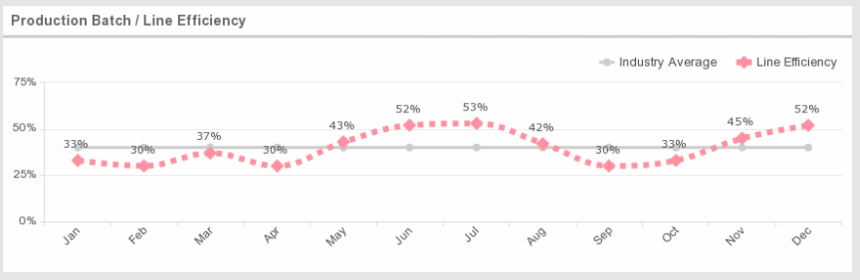
References
Garrison, R. H., Noreen, E. W., & Brewer, P. C. (2021). Managerial accounting.
Khan, Natasha, (April 10, 2018). Tech Puts Fast Fashion on Steroids. The Wall Street Journal.

